
Acute Child and Adolescent Partial Hospitalization Program

The Acute Child and Adolescent Partial Program provides intensive short term (2-4 months) therapeutic and psychiatric services to children and adolescents ages 9-17 who present with Acute to severe psychological, psychiatric, and behavioral difficulties that impede their ability to function on a day-to-day basis. This full day program offers a multidisciplinary nurturing approach to stabilize acute psychiatric symptoms for children that are at risk for hospitalization/residential placement or are returning to the community. The program operates Monday through Friday 8:30am-2:30pm.

Services Provided:  - Individual therapy  - CBT group therapy  - Family Counselling  - Medication Management  - Psychiatric evaluation  - Psychoeducation  - Social skills building by age group  - Physical Wellbeing  - Trauma Informed Care  Free Lunch | Treatment Focus:  - DSM-V Mental Health diagnoses: ex. Depression, Anxiety, Post-Traumatic Stress, Psychosis, Bipolar Disorder  - Chronic and Acute Trauma  - Suicidal Ideation or attempts  - Posed risk to self or others
RUTGERS UNIVERSITY BEHAVIOR HEALTH CARE  Acute Child and Adolescent Partial Services 183 South Orange Avenue  Newark, NJ 07101-1709  Tel: 973-972-8724  Fax: 973-972-6976 | 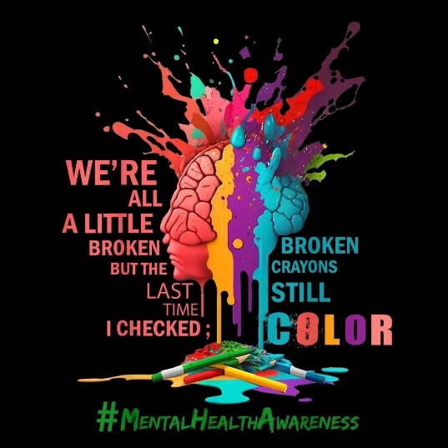
Transportation Provided


For Referrals forms and Questions call 973-972-8724

